BEZOP CANDIDATE ASSIGNMENT Documentation

Contents
Project Overview
System Architecture
Technology Requirement (Software and Hardware)
Project Flowchart
Application Screenshots
Deployment and Testing

Hardware and Software Requirement
The requirement to implement the designed software in turn of hardware and software is below :
Hardware
A computer system with the specification below :
---At least Pentium 4 Processor
---1GB Ram
---CD-ROM
---10GB HDD
Software
---Macromedia Dreamweaver CC
--- Macromedia Fireworks
---Apache Webserver(Wamp, Xampp or Tomcat)
---MySQL Server 5
---AngularJS Framework v1.6
---A browser(Internet Explorer, Mozilla Firefox, Google Chrome, Safari, Opera)

Login, Registration & Dashboard Flowchat Diagram
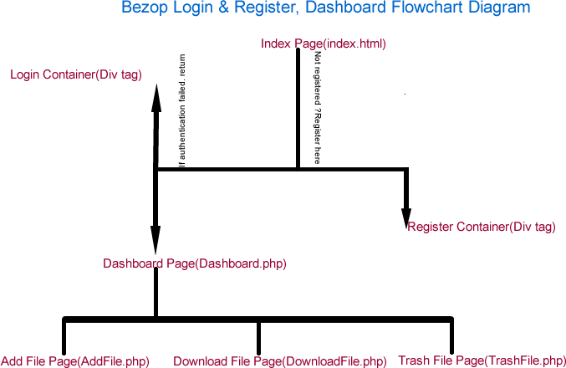
DATABASE DIAGRAM
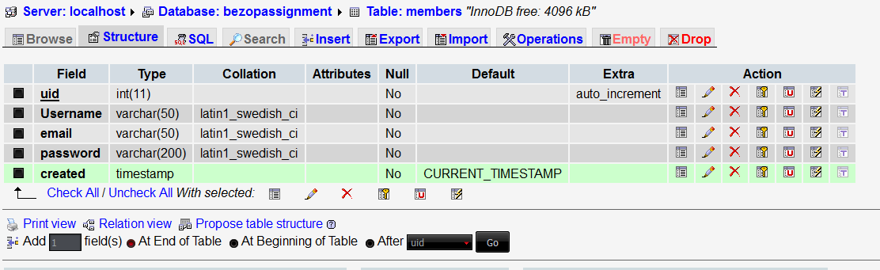
APPLICATION SCREENSHOT
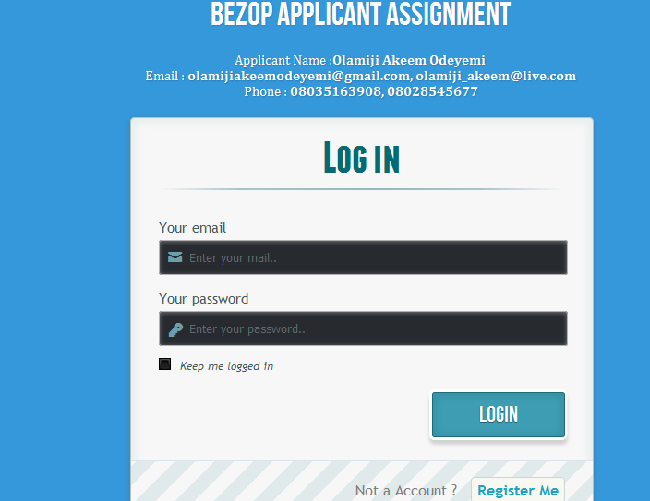
Login Screenshot
The login page of the application uses HTML, CSS, AngularJS, PHP MySQL with Bootstrap to make up the design while the angularJS is the client side scripting used to communicate with the PHP(server side language) to authenticate the user typed username and password records against the records in the MySQL database. The source code for this application can be found on github https://github.com/OlammieConcept2/BezopGCP_Assignment .

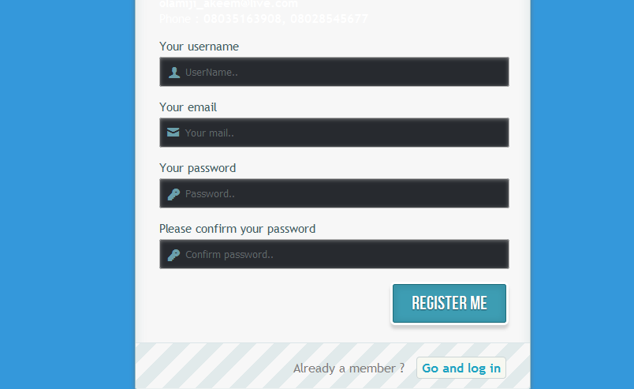
Register Screenshot
The register page uses HTML, CSS, AngularJS, PHP MySQL with Bootstrap to process the user registration data while the angularJS is the client side scripting language used to communicate with the PHP(server side language) to submit the records in MySQL database. The source code for this application can be found on github https://github.com/OlammieConcept2/BezopGCP_Assignment .

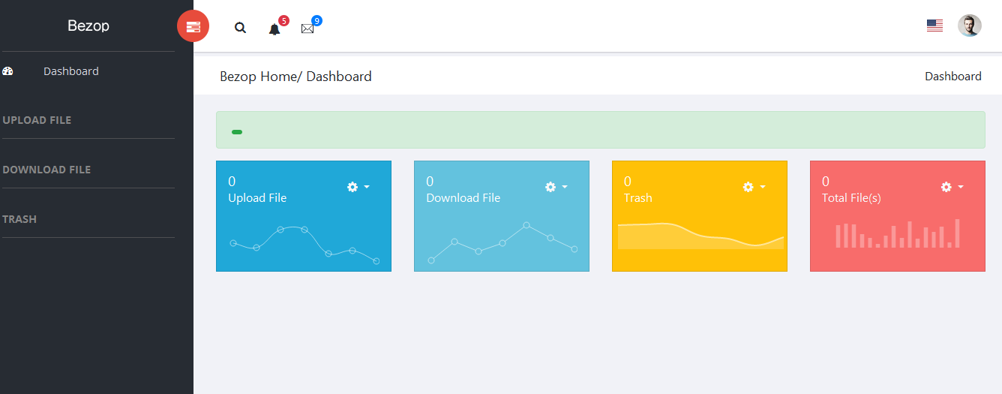
Bezop Dashboard
The dashboard page uses HTML, CSS, Bootstrap, PHP MySQL to process the user render the interface of the Home.php file of the dashboard. It has a link that allow user to navigate to the upload file page(AddFile.php), download file page(DownloadFile.php) and the trash files page(TrashFile.php). The source code for this application can be found on github https://github.com/OlammieConcept2/BezopGCP_Assignment .
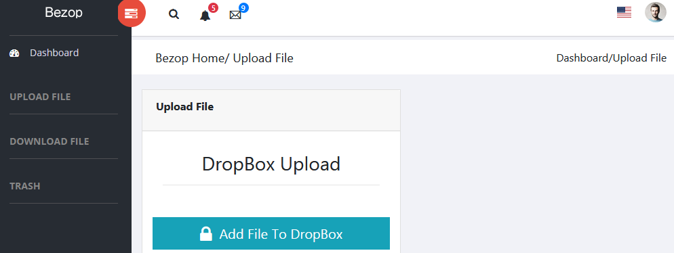
Bezop Dashboard AddFile.php
This page uploads file to dropbox and it uses the Dropbox-v2-PHP-SDK-master api to accomplish the task. The page still maintain the interface of the whole page using HTML, CSS, Bootstrap, PHP. The upload file uses the Dropbox-v2-PHP-SDK to upload, download and move files to trash. The source code for this application can be found on github https://github.com/OlammieConcept2/BezopGCP_Assignment .

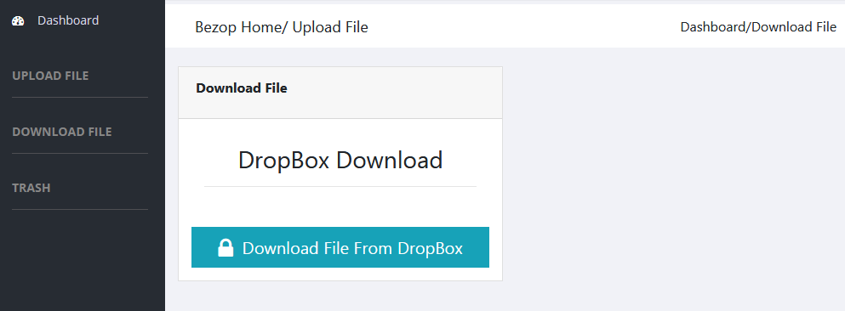
Bezop Dashboard DownloadFile.php
This page downloads file from dropbox and it uses the Dropbox-v2-PHP-SDK-master api to accomplish the task. The page still maintain the interface of the whole page using HTML, CSS, Bootstrap, PHP. The upload file uses the Dropbox-v2-PHP-SDK to upload, download and move files to trash. The source code for this application can be found on github https://github.com/OlammieConcept2/BezopGCP_Assignment
APPLICATION DEPLOYMENT
To deploy the application, follow the guide below:
1)install a webserver i.e Apache Tomcat, Wamp, Xampp
2)Create a mysql database and open the Members.sql file and copy the codes in it and run on SQL page of your web server after creating the database.
3)Copy all the files and folder from the github url and drop in the www folder of your webserver(if wamp) or in htdoc(if xampp).
4)Open the web browser of your choice i.e internet explorer, Mozilla firefox, Opera, or Safari and navigate to the location where the folder is located on your system.

Thank you for your understanding.

